Author’s guideline (References section)

The authors are henceforth instructed to give the links so that the editorial process goes on smoothly and at the earliest.

Follow the guidelines below for providing [Full Text] links in references.

- Open the full article online (let’s take reference 13 in your manuscript as an example)

- Copy the URL (ctrl+C)
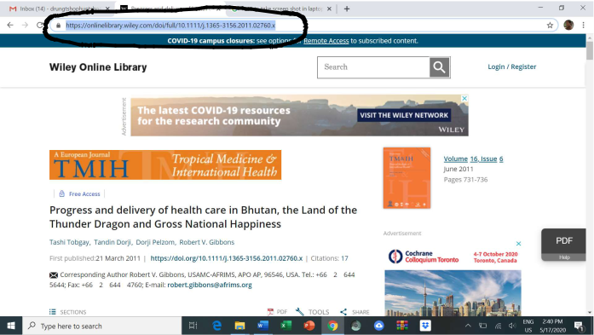

3. Mark the cursor at the end of the reference ( at the end of ref 13in your manuscript)
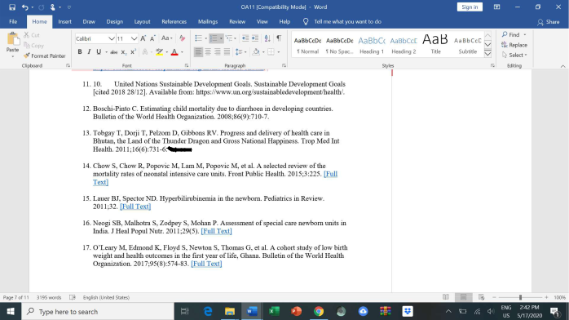

4. Press Ctrl+K (a dialogue box will appear)
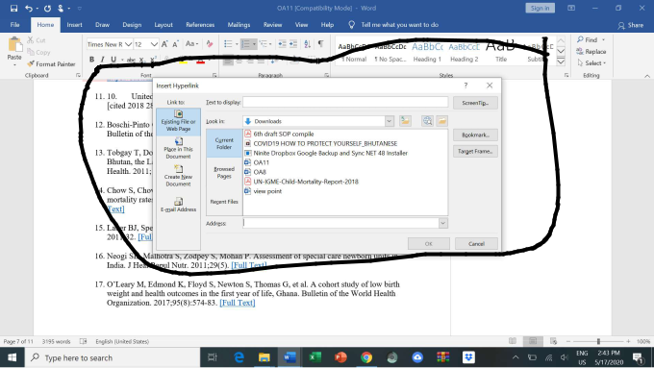

5. Paste the URL link to Address bar
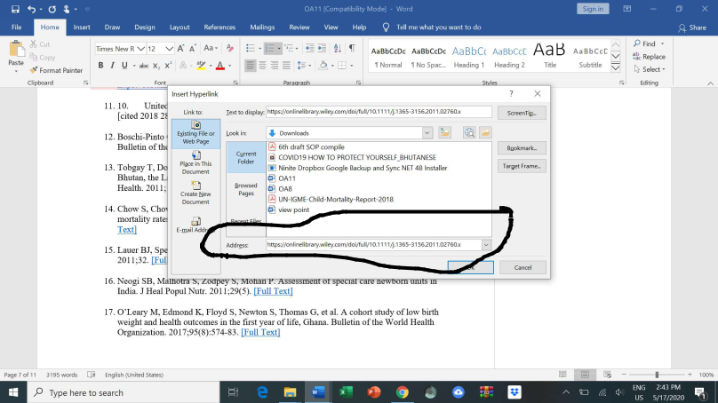

6. Erase the link in Text to display and write [Full Text] instead.
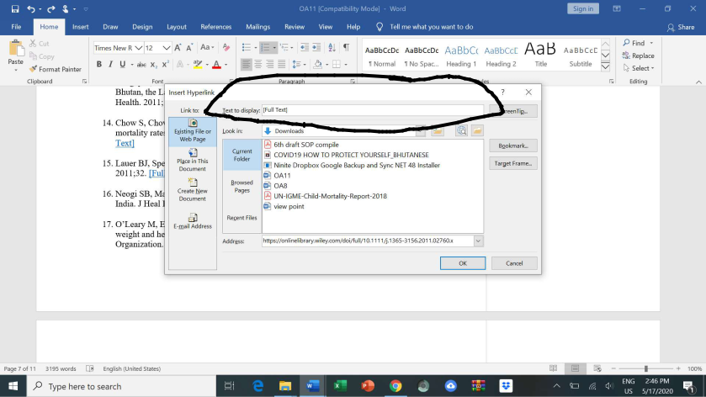

7. Press OK

